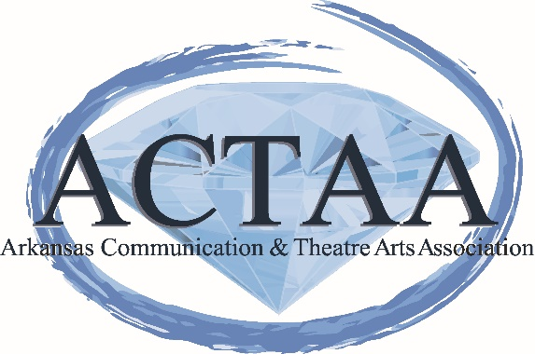

SCHOLARSHIP APPLICATION
for
CURRENTLY CERTIFIED TEACHERS
for
SPEECH COMMUNICATION, DEBATE, THEATRE, AND DANCE
AMOUNT: $500.00

MISSION STATEMENT: The Arkansas Communication and Theatre Arts Association is a community of professionals devoted to the rigorous study and ethical practice of oral communication and theatre arts as an essential discipline, life skill, and art form. Through continuing teacher education, student participation, and scholarly publication, the Association supports the efforts and continued growth of communication teachers, students, and researchers.

SCHOLARSHIP QUALIFICATIONS:
The applicant must be:
Certified Arkansas teacher in Speech Communication, Theatre Arts, and/or Dance.
Seeking continuing education, non-traditional certification and/or professional development opportunity.

APPLICATION INSTRUCTIONS:
The applicant must:
~Submit this form with the following items by the deadline to the name and address below.

~Submit two letters of recommendation (1 professional and 1 personal) and submit with this form.
~Submit plans for continuing education or non-traditional certification, or professional development opportunity, including a timeline and the institution or professional development session/workshop information.

~Write a response on the following topic:

How will your teaching improve and further the growth of Speech, Theatre, or Dance education in the state of Arkansas? Please concentrate on the following areas: 1) Student achievement and enhancement of learning 2) Professional educational goals 3) Participation in the Arkansas Communication and Theatre Arts Association.

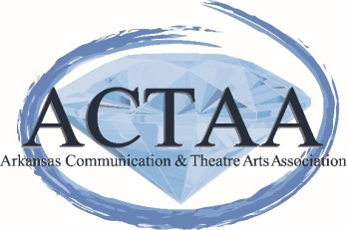
SCHOLARSHIP APPLICATION
for
CURRENTLY CERTIFIED TEACHERS
for
SPEECH COMMUNICATION, DEBATE, THEATRE, AND DANCE

Name:_____________________________________________________________

Address:___________________________________________________________

Email:_____________________________________________________________

Phone:___________________________________

Student ID # (If paying scholarship to college/university.) ______________________________

Institution Name and Address Scholarship should be mailed___________________________________________________________________________ _________________________________________________________________________________ _________________________________________________________________________________

Applications should be received by March 6, 2020.

Jennifer Akers, Scholarship Chair
18 Talladega Loop
Cabot, AR 72023

OR

jennifer.akers@cps.k12.ar.us

