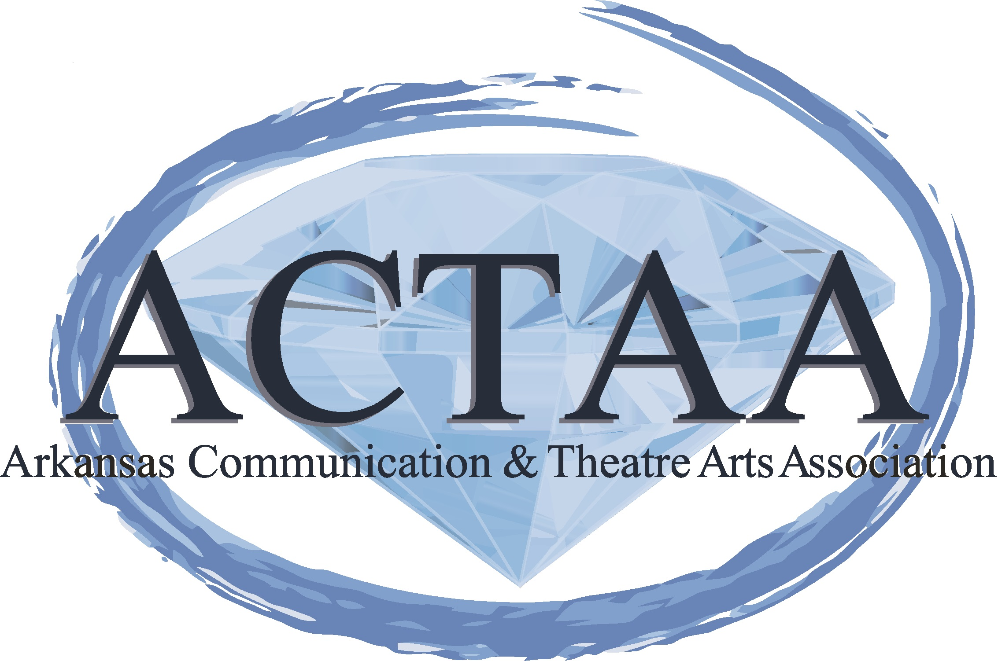
GREETINGS, ACTAA members!!!
I have been given the adventure of planning this year’s Fall Conference, which will be held September 5th, 6th, and 7th at the downtown Marriott Hotel in Little Rock. I chose this venue because it promises to be gorgeous, restful, is centrally located for us to get to, and the perfect location for this year’s conference theme, Rejuvenation in the ROCK: Revitalizing Yourself and Your Classroom.

The older I become in my teaching career, the more I can see how important it becomes to regroup, reflect, rejuvenate and prevent burn-out as much as possible. 10 years have flown by so quickly!!! So easily we get caught up in making sure every curriculum map is followed to a tee, every classroom management style is incorporated for our sanity, every competition piece or debate case is perfected, every dance step is written down for later teaching, every costume concept and scenic design has been painstakingly created. The long hours are overwhelming and exhausting. This conference will focus on how we can prevent teacher burnout, through creative PD sessions, through cheerleader/keynote speakers, through just breaking down the walls and realizing you are NOT ALONE in this artistic educational adventure, which is something we can all take value from for SURE!!!
Truthfully, as I become more involved in ACTAA, I have noticed a shift in PD offerings towards being more about the competitive aspects of our organization, and I think this is unfair to ALL our members, especially our new members. Teaching is overwhelming enough! This organization is about so much MORE than just competition at the national level. I feel we need to be reaching ALL of our members, at all times, at all levels and diversities as much as possible.

Because of the competitive nature and shift in focus of our organization, I will say that I have also observed a great deal of tearing down the professional bonds that we all commonly share.. Fall Conference 2019 will be designed to rebuild these bonds and help you get to know your fellow ACTAA members on a deeper level, many of whom we only see at tournaments. My hope is that this conference will provide you a network of folks you can reach out to for assistance, for feedback, or even a giggle. I feel this is SO important on this journey in education, which can be lonely at times. To have a network of support, to know each of your fellow coaches, to build a professional network of trustworthy folks you can rely on.
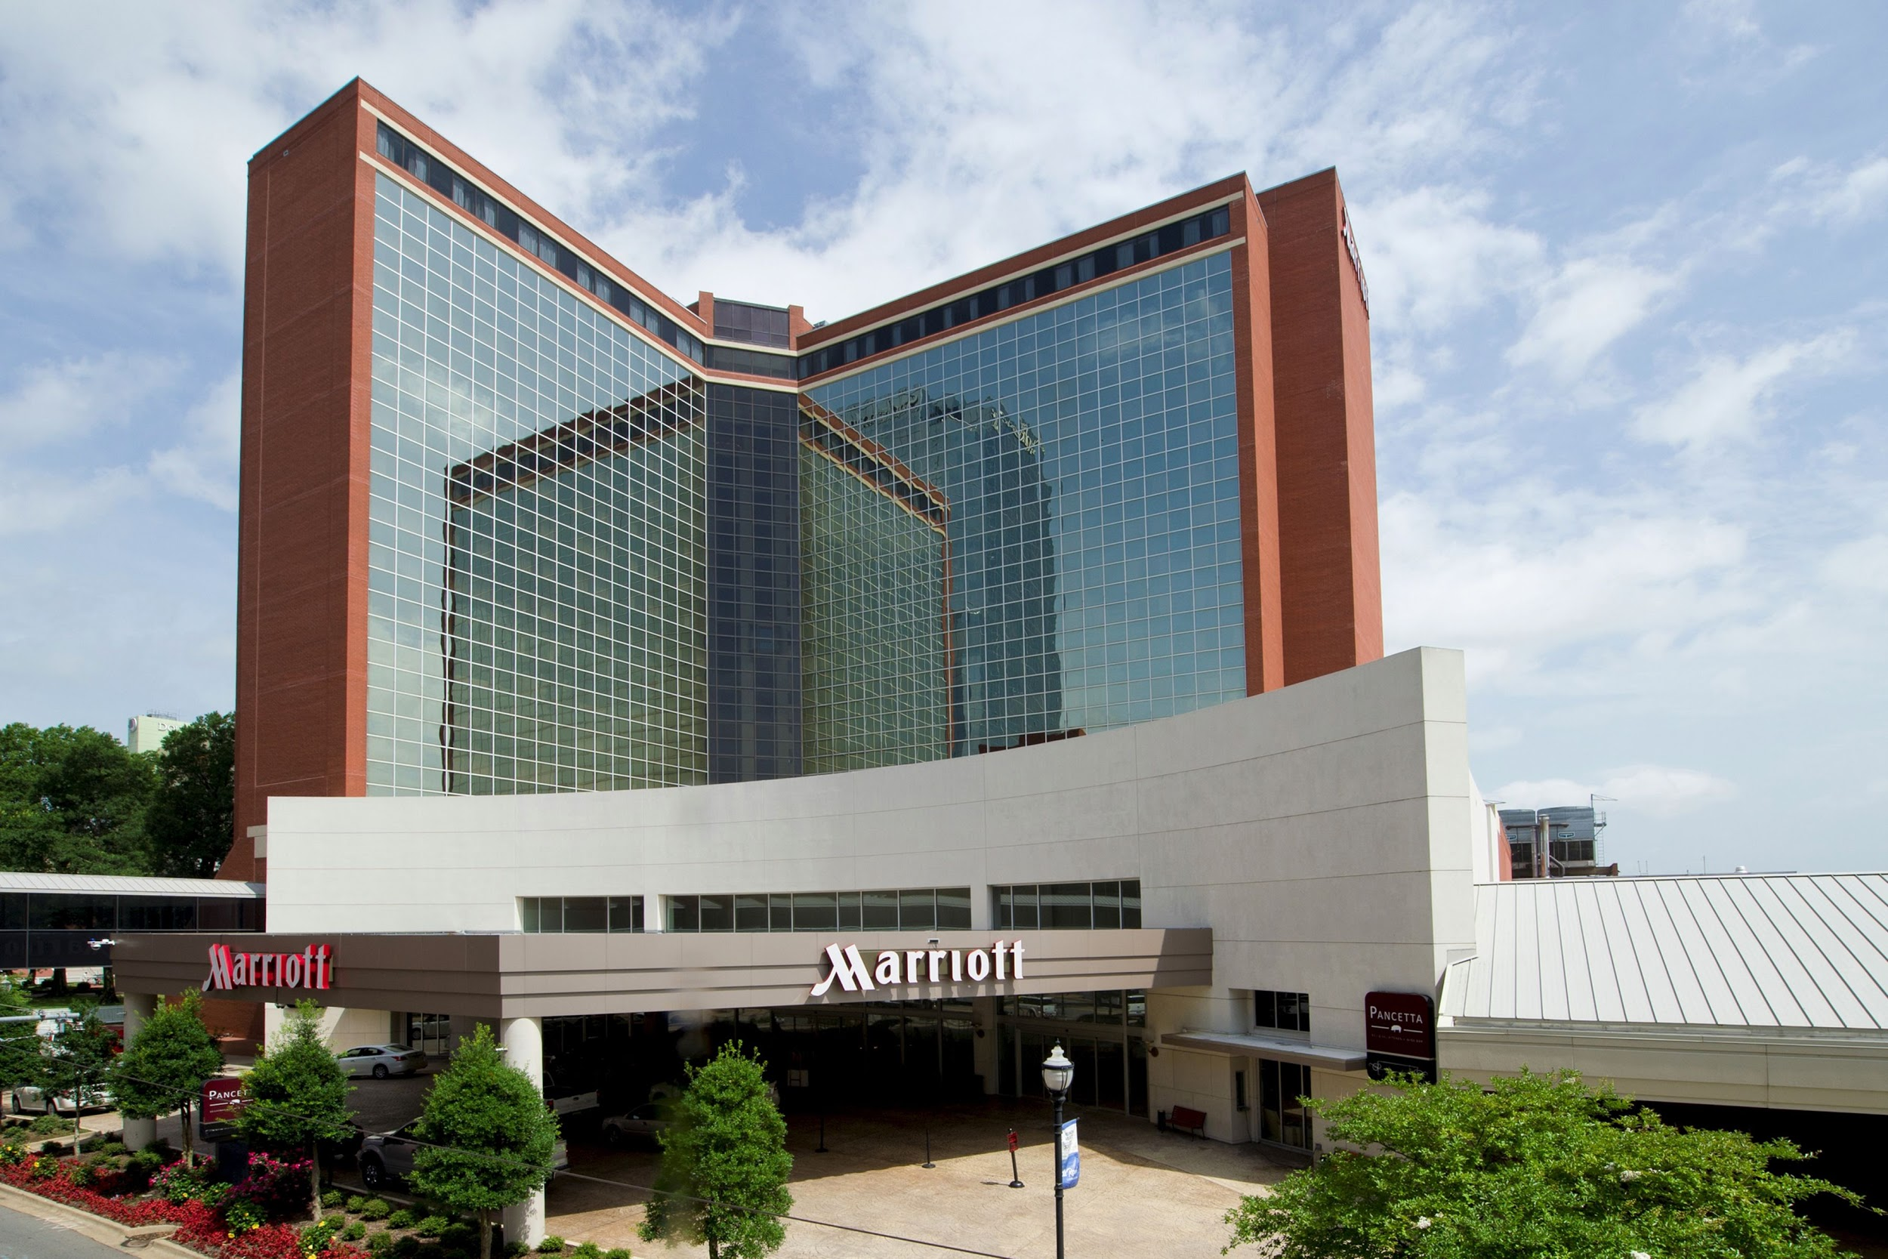
Hotel Rooms are $133 a night and can be reserved NOW!!!! The hotel is built for a breathtaking view no matter where you stay…one side looks out over the river and the other side looks over the Little Rock skyline! Please reserve your rooms quickly as they will go fast. Please call the reservation line through the Marriott to reserve your room at 1-877-759-6290. A credit card or one night’s deposit will be required to secure a room out of this block. Cancellations must be received 24 hours in advance prior to arrival or 1 night of room and tax will be assessed. Reservations MUST be completed by August 23, 2019. Do not put this off as our block will be dissolved by that time frame.

Fall Conference 2019 Registration Fees
Early Bird total (by August 23rd)
$185 per person.
From August 24 to August 30th:
$225 per person
August 31st to September 4th :
$275 per person
Day of Registration:
$330 per person
If you choose to attend one Single Day only
Cost Early = $125
versus
Day of Registration = $250
We welcome guests, however must let the hotel know ahead of time:
Guest Meals: Friday Eve Dinner $50 per guest/Saturday Lunch would $40 per guest

NOTE FOR ALL: If you register and do not come not cancelling your registration with ACTAA by August 30th, you will forfeit all your registration fees.
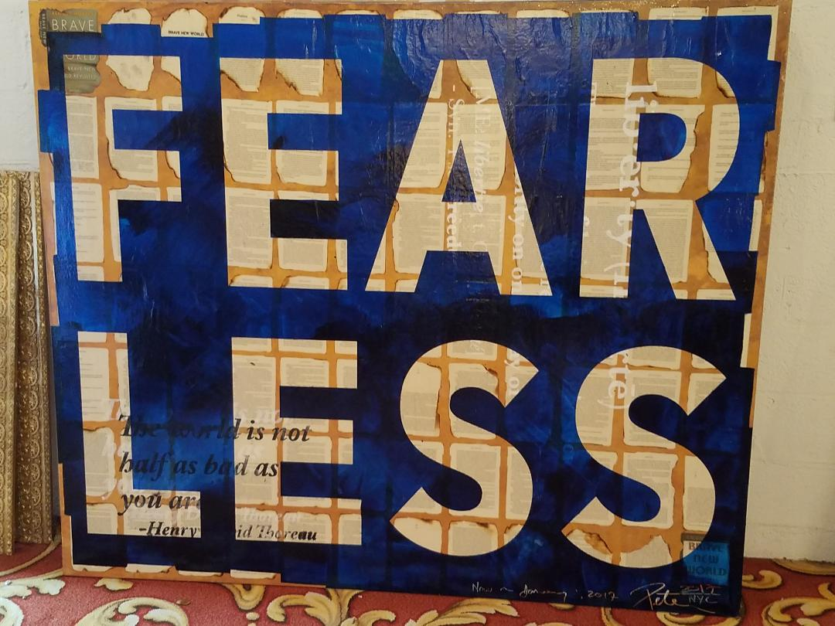
It is going to be a weekend filled with rest and rejuvenational-styled activities, along with all our business we also have to get accomplished that weekend. We will come together for wonderful food, fellowship, and will have motivational keynote speakers meant to entertain and build you up, which is so important. It is going to be an event you are not going to want to miss, and I sincerely hope to see you all there!!

Please take a moment to complete the following Google Survey before July 31st. Information you provide will remain anonymous but will also help us steer the weekend towards valuable information for each of us!
https://docs.google.com/forms/d/1YnYBSh38GOScJcCCh5KV-qJBGM1yGH3B2jWeJRRwNTA

SEE YOU IN THE ROCK this fall!!!!!

Sincerely,
Brandon Box-Higdem
ACTAA 2nd Vice President

